Name | Hatim Yusuf Sawai
UID no. | 2021300108
Experiment No. | 1

AIM: | Use the formatted input/output statements, operators and expressions of C language
Program 1
PROBLEM STATEMENT: | Write a C program to input 2 numbers. Perform addition, subtraction, multiplication, division and modulus and display output.
ALGORITHM: | - START  - Input a,b  - add = a+b  sub = a-b  mul = a*b  div = a/b  mod = a%b  - Print add,sub,mul,div,mod  - STOP
FLOWCHART: | 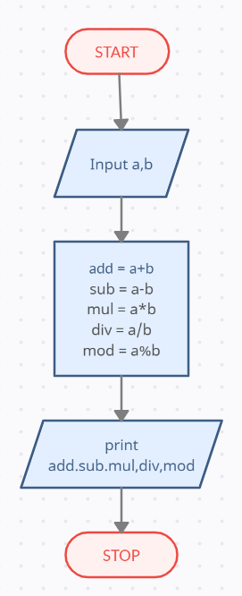
PROGRAM: | #include<stdio.h>  int main()  {  int a,b;  printf("Enter 2 numbers:\n");  scanf("%d %d",&a,&b);  printf("Addition: %d\nSubtraction: %d\nMultiplication: %d\nDivision: %.2f\nModulus: %d",a+b,a-b,a*b,(float)a/(float)b,a%b);  return 0;  }
RESULT:
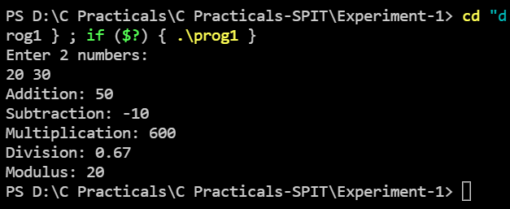
Program 2
PROBLEM STATEMENT: | Write a C program to convert days into year, month and days.
ALGORITHM: | - START  - Input days  - years = days/365  - days = days%365  - months = days/30  - days = days%30  - weeks = days/7  - days = days%7  - print years,months,weeks,days  - STOP
FLOWCHART: | 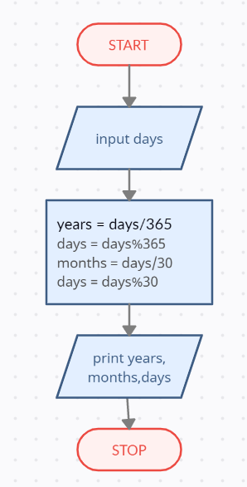
PROGRAM: | #include<stdio.h>  int main()  {  int days,months,years,weeks;  printf("Enter the number of days:\n");  scanf("%d",&days);  years = days/365;  days = days%365;  months = days/30;  days = days%30;  weeks = days/7;  days = days%7;  printf("%d years %d months %d weeks %d days",years,months,weeks,days);  return 0;  }
RESULT:

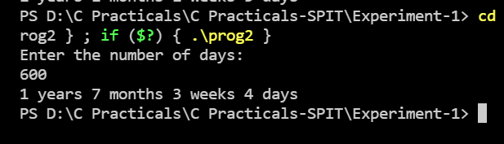
Program 3
PROBLEM STATEMENT: | Write a C program to find the third angle of a triangle if two angles are given.
ALGORITHM: | - START  - Input a,b  - c = 180 – a - b  - if a+b+c = 180 && a>0 && b>0 && c>0  print c  - else  print Invalid angles  - STOP
FLOWCHART: | 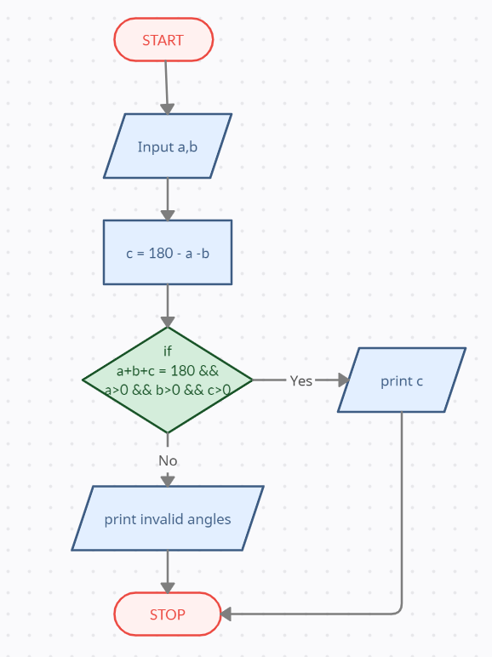
PROGRAM: | #include<stdio.h>  int main()  {  int a,b,c;  printf("Enter the 2 angles:\n");  scanf("%d %d",&a,&b);  c = 180-a-b;  if(a+b+c == 180 && a>0 && b>0 && c>0)  {  printf("The third angle = %d", c);  }  else  {  printf("Invalid angles! Please try again!");  }  return 0;  }
RESULT:
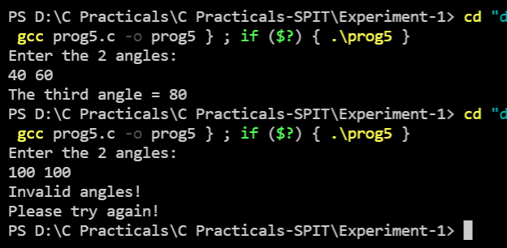
Program 4
PROBLEM STATEMENT: | Write a C program temp.c that accepts a temperature in Fahrenheit and prints the corresponding temperature in Celsius.
ALGORITHM: | - START  - Input f  - c = 5 * (f - 32) / 9  - print c  - STOP
FLOWCHART: | 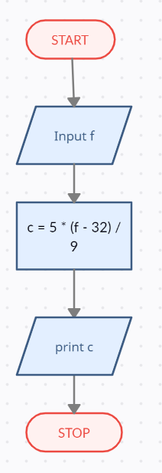
PROGRAM: | #include <stdio.h>  int main()  {  float f, c;  printf("Enter temprature in fahrenheit:\n");  scanf("%f", &f);  c = 5 * (f - 32) / 9;  printf("Temp %f in degree Celcius = %.2f C",f,c);  return 0;  }
RESULT:
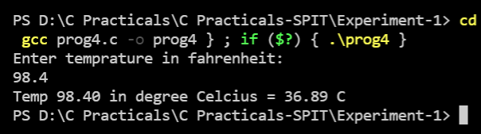
Program 5
PROBLEM STATEMENT: | Write a C program intrst.c that calculates the total interest income on amount Rupees 5 lakhs in a period of 10 years. Show the results for simple interest, compounded interest when the compounding is done annually,semi-annually, quarterly, monthly and daily. Assume that the interest rate is 3.5% per year.
ALGORITHM: | - START  - amt = 500000  rate = 3.5  yrs = 10  - si = amt * rate * yrs / 100  - ci1 = amt*pow((1+rate/100),yrs) – amt  - ci2 = amt*pow((1+(rate/2)/100),2*yrs) - amt  - ci3 = amt*pow((1+(rate/4)/100),4.0*yrs) – amt  - ci4 = amt*pow((1+(rate/12)/100),12*yrs) – amt  - ci5 = amt*pow((1+(rate/365)/100),365*yrs) – amt  - print si,ci1,ci2,ci3,ci4,ci5  - STOP
FLOWCHART: | 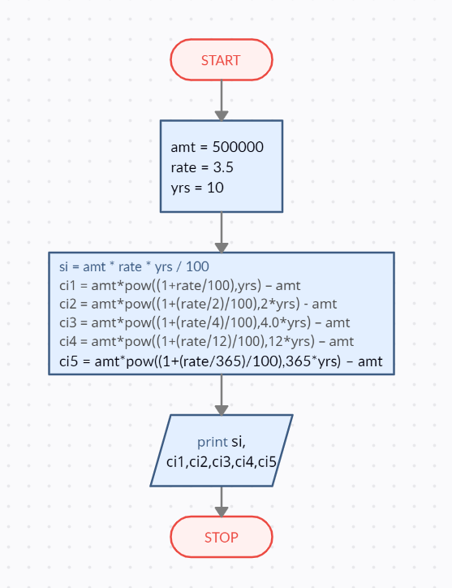
PROGRAM: | #include<stdio.h>  #include<math.h>  int main()  {  double amt = 500000,rate = 3.5,yrs = 10;  double si,ci1,ci2,ci3,ci4,ci5;  si = amt * rate * yrs / 100;  ci1 = amt*pow((1+rate/100),yrs) - amt;  ci2 = amt*pow((1+(rate/2)/100),2*yrs) - amt;  ci3 = amt*pow((1+(rate/4)/100),4.0*yrs) - amt;  ci4 = amt*pow((1+(rate/12)/100),12*yrs) - amt;  ci5 = amt*pow((1+(rate/365)/100),365*yrs) - amt;  printf("Simple interest on Rs. 500000.00 in 10 years = Rs. %.2f\n", si);  printf("Compound interest on Rs. 500000.00 in 10 years annually = Rs. %.2f\n", ci1);  printf("Compound interest on Rs. 500000.00 in 10 years semi-annually = Rs. %.2f\n", ci2);  printf("Compound interest on Rs. 500000.00 in 10 years quarterly = Rs. %.2f\n", ci3);  printf("Compound interest on Rs. 500000.00 in 10 years monthly = Rs. %.2f\n", ci4);  printf("Compound interest on Rs. 500000.00 in 10 years daily = Rs. %.2f\n", ci5);  return 0;  }
RESULT:
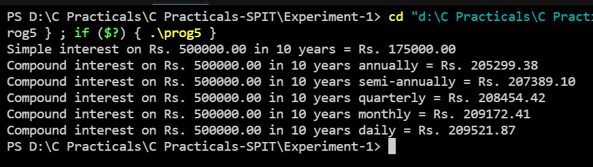
CONCLUSION: | In this experiment, we learned about the different types of operators and expressions, while also learning how to take input and print out all sorts of expressions from and to the user respectively.

